Camp Belly Rub daycare and boarding registration packet.
853 Flatbush Road
Kingston, NY 12401
845-514-2727
WWW.CampBellyRub.dog- come visit us
CampBellyRubKingston@gmail.com- contact us or make a reservation

Welcome to Camp Belly Rub;
We are extremely pleased that you have chosen to use our facility for your dog’s daycare and boarding needs. We are confident that you will find our services one-of-a-kind.
To schedule the initial evaluation, please call or fill out an online request. Evaluations are conducted by appointment only. If you schedule online, we recommend that you complete the forms to expedite your part in our temperament evaluation.
Initial evaluations are scheduled at specific times of the day in order to maintain a structured day for the dogs and ensure they have time for all their scheduled activities. If you are running late, please give the office a courtesy call so that we can either hold your spot or reschedule for another time.
Enclosed is your Registration Packet for daycare and boarding services. Please print a copy of this packet or complete all forms online BEFORE your scheduled evaluation. At the evaluation, a member of our staff will review the materials with you and answer any questions you may have.
This Registration Packet contains: A) Service Agreement – please sign and date B) Client Information Form – please fill out in its entirety C) Daycare Application – please fill out a separate form for each dog that will be attending daycare D) Emergency Contact & Vet Authorization Form – please sign and date E) Credit Card Authorization Form – this form is optional for credit card processing
In addition, please provide a copy of your dog’s most current vaccination records. Vaccinations should include rabies, bordetella, and parvo/distemper vaccinations. You can contact your vet’s office and ask that they email ( CampBellyRubKingston@gmail.com) this information to us prior to your evaluation appointment.
We want to ensure your evaluation goes smoothly and that your experience with Camp Belly Rub is a positive one. The day of your evaluation, the evaluator will provide you with additional materials about our policies, procedures, advice on dog behavior, and more information about our other services.

Camp Belly Rub, LLC
853 Flatbush Road, Kingston, NY
845-514-2727
WWW.CampBellyRub.dog- come visit us
CampBellyRubKingston@gmail.com- contact us or make a reservation

This DOG DAYCARE & BOARDING AGREEMENT (Agreement”) is made this _____ day of _________________, 20___, by and between Camp Belly Rub, LLC ( “CBR”) and ___________________________ (hereinafter known as “Pet Owner”). WHEREAS, CBR wishes to provide dog daycare and/or boarding services and Pet Owner wishes to accept such service on the terms and under the conditions recited below; The Parties, intending to be legally bound, hereby agree as follows:
1. Prices for Services are detailed in our Services & Pricing Guide. Prices are subject to change. Payment for all services is required in advance. Cash, check, and credit card payments are accepted.
2. CBR reserves the right to not accept a dog into daycare or boarding for any reason. All rules of the camp are subject to change at the sole discretion of CBR.
3. CBR agrees to provide a cageless, off-leash environment for your dog to exercise and socialize with other dogs and our staff during daycare hours. CBR boarding services may not be cageless; dogs may be kenneled overnight.
4. In the event that your dog becomes ill while in the care of CBR we will attempt to contact you. If you are not available, we will attempt to contact your veterinarian. At the discretion of CBR, your dog may be taken to an Emergency Veterinary Clinic or a veterinarian of CBR’s choice. It is understood that all expenses incurred due to your dog’s illness or accident are the sole responsibility of the Pet Owner. Any expenses due CBR are to be paid in full at the time that you pick your dog up from CBR. We will not bill you or accept partial payment. Pet Owner authorizes CBR and its representatives to obtain medical treatment for the dog, in the event of an illness or accident.
5. Pet Owner agrees to hold CBR, its , owners, agents, employees and lessor of the premises, harmless from any and all claims for loss or injury (including legal fees) which may be alleged to have been caused directly or indirectly to any person or thing by the act of the dog, and Pet Owner personally assumes all responsibility and liability for any such claim. Pet Owner further agrees to hold aforementioned parties harmless from any claim (including legal fees) for loss of the pet by disappearance, theft, death or otherwise, and from any claim or damage or injury to the dog whether such loss, disappearance, theft, damage or injury be caused or alleged to be caused by the negligence of CBR or any of the parties aforementioned. Pet Owner assumes sole responsibility for and agrees to indemnify and save the aforementioned parties harmless from any and all loss and expense (including legal fees) by reason of liability imposed by law upon any of the aforementioned parties for damage because of bodily injuries, including death at any time resulting wherefrom, or sustained by any person or persons, including Pet Owner, howsoever such injuries, death or damage to property may be caused, and whether or not the same may have been caused or alleged to have been caused by the negligence of the aforementioned parties or any of their employees, agents, trainers or any other persons
6. Pet Owner certifies that he/she is the actual owner of the dog, or is the duly authorized agent of the actual owner whose name is entered above.
7. Pet Owner represents that the pet is free of any infectious disease and is vaccinated for DHPP (Distemper, Hepatitis, Parainfluenza, Parvo), Bordatella, and Rabies. Pet Owner represents the pet is also free of contagious parasitic problems, whether internal or external (including fleas & ticks), and is free of any contagious skin disorder.
8. Pet owner is aware that the CBR center is a cageless daycare facility by day and caged kennel by night, and is aware that there is inherent risk of illness and injury when dealing with animals.
9. This Agreement sets forth the entire agreement between the Parties with regard to the subject matter hereof. This agreement may be modified, superseded, or voided only upon the written and signed agreement of all the Parties.
10. Resolution of Disputes. Any controversy or claim arising out of or related to this Agreement shall be settled by arbitration administered by the American Arbitration Association. Judgment upon the award rendered by the arbitrator may be entered in any court having jurisdictions thereof. The proceedings on such arbitration shall be held in the State of New York unless the parties otherwise agree. The laws of the Stare of New York shall apply to the dispute. The prevailing party shall be entitled to an award of attorneys’ fees and costs. Pet owner’s damages, if any, shall be limited to the monetary value of said pet.
11. Pet Owner represents that the information in the attached Dog Daycare application is true and that CBR is reasonable to rely on the accuracy of said information.
I have read and understand the terms set forth above. I agree to abide by all the terms, conditions and statements of this CBR DOG DAYCARE & BOARDING AGREEMENT.
Signature: _________________________________
Print Name: __________________________________ Date: ____________
Camp Belly Rub Representative Signature:_________________________________Date:____________
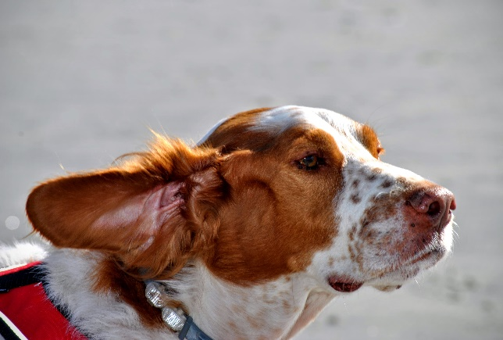
Camp Belly Rub
853 Flatbush Road
Kingston, NY 12401 845-514-2727
WWW.CampBellyRub.dog- come visit us
CampBellyRubKingston@gmail.com- contact us or make a reservation

Client Information
It is important that you provide all of the information below so that we have the correct contact information on file. Please note, Camp Belly Rub uses email to send invoices and confirmation of reservations or cancellations. Please be sure to provide a valid email address. If any of the information below changes, please contact our office so we may update our records.
Primary Owner
First Name ________________________ Last Name ___________________________
Address ________________________________ City __________________ State _____ Zip _______
Please circle the phone number that is best to reach you during business hours:
Home Phone ____________________________ Work Phone ____________________________
Cell Phone ____________________________
Email ______________________________________________
Secondary Owner (authorized to schedule service & make decisions regarding the care of your pet)
First Name ________________________ Last Name ___________________________
Home Phone ____________________________ Work Phone ____________________________
Cell Phone ____________________________
Email ______________________________________________

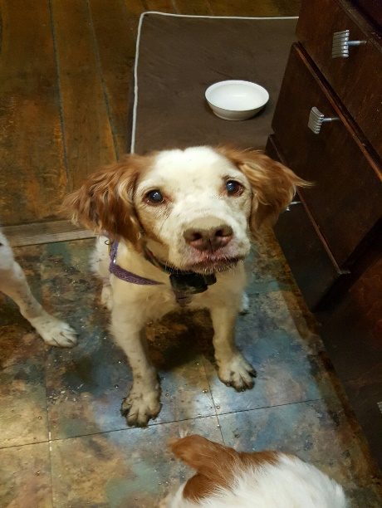
Camp Belly Rub
853 Flatbush Road
Kingston, New York 12401 845-514-2727
WWW.CampBellyRub.dog- come visit us
CampBellyRubKingston@gmail.com- contact us or make a reservation
Daycare and Boarding Application
Pet Information
Dog’s Name ________________ Breed ________________ M / F Birthday __________ Spay/Neuter___ ( all dogs over 6 months MUST be spayed or neutered)
How did you hear about us? _________________________________________________________
Are you primarily seeking daycare or boarding? (Circle One or Both)
Do you administer monthly flea and tick preventative? Y / N (what kind? _________________ Monthly heartworm preventative? Y / N
How old is your dog? ______ (Puppies under 6 months not required to have rabies vaccination)
Does your dog have any allergies that you are aware of? (if so please list) ________________________ ____________________________________________________________________________________
Does your dog play with toys? Y / N
Has your dog had any formal obedience training? Y / N
Additional Information
1. How often has your dog interacted with other dogs? (dog parks, other daycares, family and friend’s dogs) – ____________________________________________________________________________________ If so how does your dog behave with other dogs? _______________________________________________ __________________________________
2. Has your dog ever growled or snapped at anyone for taking his/her food or toys away? Y / N
3. Has your dog ever shared food or toys with other animals? Y / N
4. Is your dog afraid of anything such as loud noises, thunderstorms, men? ____________________________
5. Are there any other triggers we should know about? ____________________________________________
6. Has your dog ever bitten or broken skin of any person or dog, attacked a small animal (bird, squirrel, cat, etc.), or do they have a record with the city government or animal control of a vicious dog attack.
Y / N If your answer is yes, please explain: _____________________________________________________________________________________
7. Is your dog a rescue? Y / N Is there any background knowledge you can share with us? _____________________________________________________________________________________
8. Is your dog familiar with any commands? Y / N If yes, please let us know which ones _____________________________________________________________________________________
9. How does your dog interact with:
Large dogs: _____________________________________
Small dogs:_____________________________________
Puppies:________________________________________
Seniors:________________________________________
10. How does your dog react to strangers? People at your door?
___________________________________________________________________________
11. Does your dog have any issues with:
Mouthiness:_______________________________________________________________________
Barking:___________________________________________________________________________
Digging:____________________________________________________________________________
Climbing/ Jumping ( HOW HIGH)_________________________________________________________
Eating non food objects ( poop included)_________________________________________________

12. Does your dog have any previous hip/ knee injury/ ailment? _______________________________________________________
13. Does your dog have any exercise restrictions? ____________________________________________
14. Any other health related issues we need to be aware of? ____________________________________________________________________________________
15 Does your dog like to be brushed? Y / N Any sensitive areas on the body they do not like touched (i.e. feet) ____________________________________________________________

16. What else do we need to know about your dog?

What are your expectations of Camp Belly Rub in relation to your dog?

A counselor should be taking copious notes and sharing with the pet parent what they can expect from us. Review the additional handout with them and ask them to initial this form once that handout has been covered.
Pet Parent initial_____________
Camp Counselor initial___________
The above initials indicate a representative from Camp Belly Rub has reviewed expectations regarding service and possible side effects/ injuries associated with day care/ boarding.

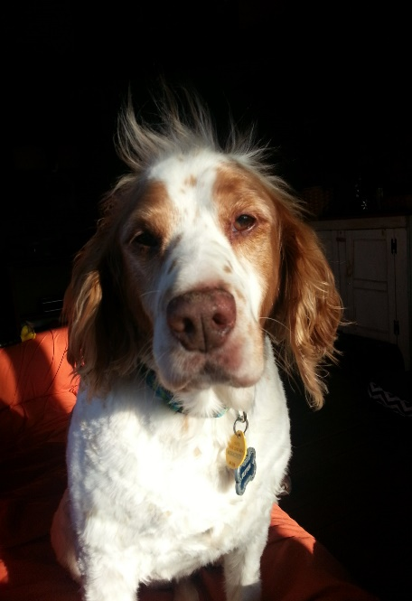
Camp Belly Rub
853 Flatbush Road
Kingston, NY 12401
845-514-2727
WWW.CampBellyRub.dog- come visit us
CampBellyRubKingston@gmail.com- contact us or make a reservation

Emergency Contact & Vet Authorization
Your emergency contact should be someone local and someone that, in the event of emergency, has access to your home.
Emergency Contact Name ______________________________________
Home Phone __________________ Work Phone __________________
Cell Phone __________________
Vet Information and Release Form
Vet Clinic ____________________________________________________
Address ___________________________________ City ________________ State _____ Zip _______
Phone _____________________________
I understand that in the event of an emergency, Camp Belly Rub, LLC will make every attempt to contact me. In the event that I cannot be reached, I authorize the following:
In the event of illness or injury, I authorize Camp Belly Rub, LLC to seek appropriate medical treatment for my pet. I understand that every effort will be made to take my pet to the vet clinic specified on the emergency form if the situation permits however; Camp Belly Rub, LLC has the authority to seek treatment at any veterinary clinic.
Furthermore, I agree to reimburse Camp Belly Rub, LLC within 14 days of incident for veterinary fees and all related costs including transportation in any amount up to $_____________ (please specify dollar amount per pet. Common amounts are $200, $1000, or unlimited).
This release does not expire and will remain valid for all future Camp Belly Rub, LLC services.
Client Signature _____________________________________ Date _______________
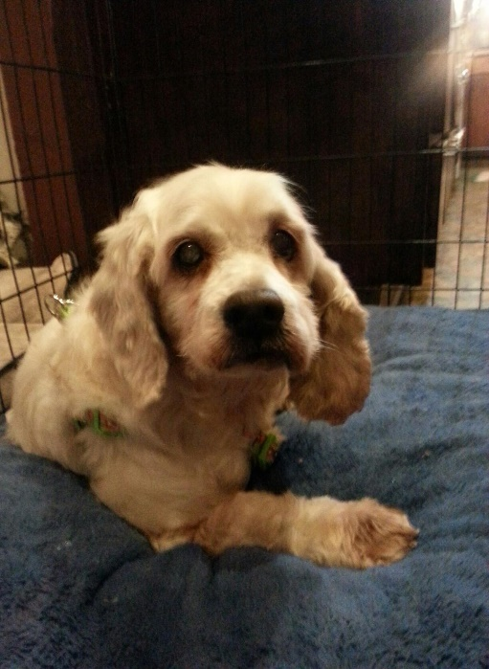
Camp Belly Rub
853 Flatbush Road
Kingston, New York 12401
845-514-2727
WWW.CampBellyRub.dog- come visit us
CampBellyRubKingston@gmail.com- contact us or make a reservation

Credit Card Authorization (optional)
I authorize Camp Belly Rub, LLC to automatically charge the credit card, listed below, as payment for invoices for any and all future Camp Belly Rub, LLC services. I understand that Camp Belly Rub, LLC will provide me with an invoice either by US Mail or email disclosing the amount of charges.
Client Information
Name (as it appears on the card) ________________________________________________
Billing Address _________________________________ City________________ State _____ Zip _____
Contact Number _____________________________ work / cell / home (please circle)
Email Address _________________________________________________
Credit Card Information
Account Number ___________________________________________
Expiration Date ____________
VCode ___________ (3-digit code on back of card)
Visa / MasterCard / Discover (please circle) *Note we do not take American Express
I understand that this information will be retained on file for any future invoice charges. If you would like to change your credit card information, you will need to submit a new form to our office.
Client Signature ___________________________________________ Date ____________
Printed Name _____________________________________________
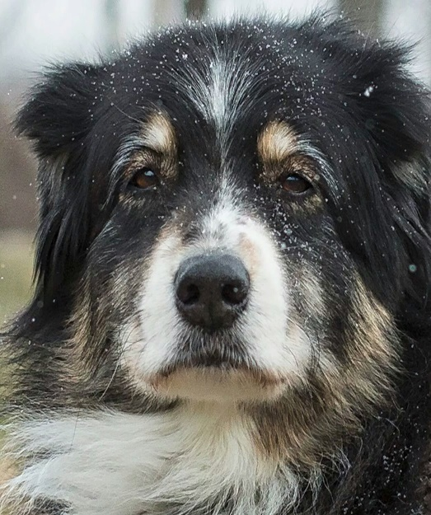
What you and your dog can expect from Camp Belly Rub

First and foremost, you can expect professional and respectful interactions with our staff. All questions need to be answered to your satisfaction. If our Counselors do not have the adequate time, they will offer to contact you at a time that allows for a comprehensive and thorough answer.
You will receive honest and unbiased information. If you ask for an opinion, we will share our own perspectives with you but we strive to promote an environment where every side and option can be discussed. You will find, as a dog owner, there are many perspectives on training, nutrition, discipline, etc.
Your dog may experience the following after a day at camp:
We are dealing with a group of dogs. We do everything we can to prevent any inappropriate behavior but at times, accidents will happen. Our staff stays up to date on monitoring behavior (to deescalate if needed) and all protocol to prevent or react appropriately to unwanted behavior. While we would like to guarantee there will never be an injury from another dog, that is simply not possible. We have outlined what will happen in the event of any injury in other documents.
They may sleep longer than normal- This is a good thing. They are physically and intellectually tired. A tired dog is a good dog! Watch for a dog that may be a bit stiff or limping. If this gets worse of hampers them from engaging in “normal” home activities…Monitor and assess. After a fun day playing with their friends, some soreness is expected.
Their eating habits may differ. They may eat more as they have burned more calories (as your dog continues in day care, you may want to monitor their weight to ensure they are being fed enough to maintain a healthy weight.). Initially, some may actually want less food as sleep will overrule. In any case, make sure when they do eat, it is not at a gulping fast paced speed as this may support more air in their digestive tract which can lead to conditions as simple as extra gas to potentially fatal, bloat (more common in bigger, barrel chested dogs).
Your dog may have some loose stool. As dog parents we monitor our dogs’ stool. With increased activity and water, their stool may be loose. If this continues for more than a day, worsens, or is accompanied by vomiting, contact your Vet. Otherwise, it is a normal by-product of the change in activity.
Any major changes in behavior should be noted such as, chewing at themselves, scratching, changes in breathing (panting excessively). If you notice changes; monitor, assess and contact your vet for direction.
We will also monitor your dog . If a normally active dog is more reserved, a reserved dog is super hyper, coughing, itching, etc., we will communicate these types of changes to you.
Any behaviors we notice or you describe to us, may prompt a recommendation speak to your vet or to one of our trainers. Please know this is not mandated but a suggestion that may provide a solution to an issue that has been identified.
Any questions or concerns not answered to your satisfaction, please contact my personal cell 845-417-8992.
Thank you, Lynn and Tracey- Chief Camp Counselors!

